- File format, size of some downloadable materials are not provided in the website. Also certain downloadable materials have file size mentioned as zero (0 kb)

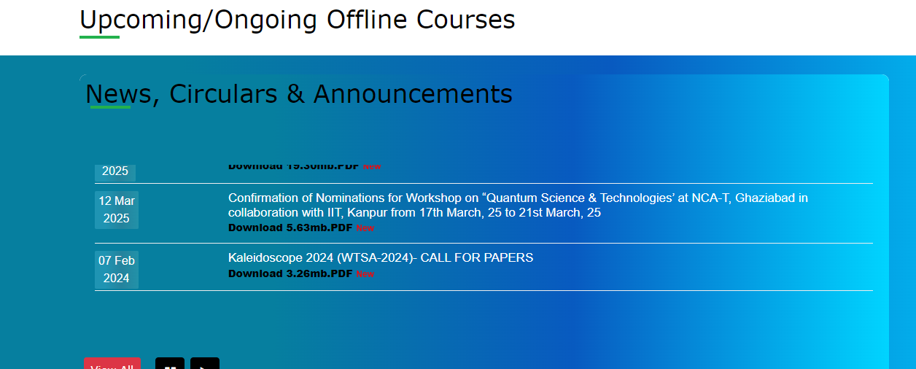

- Broken Links are found in the website.

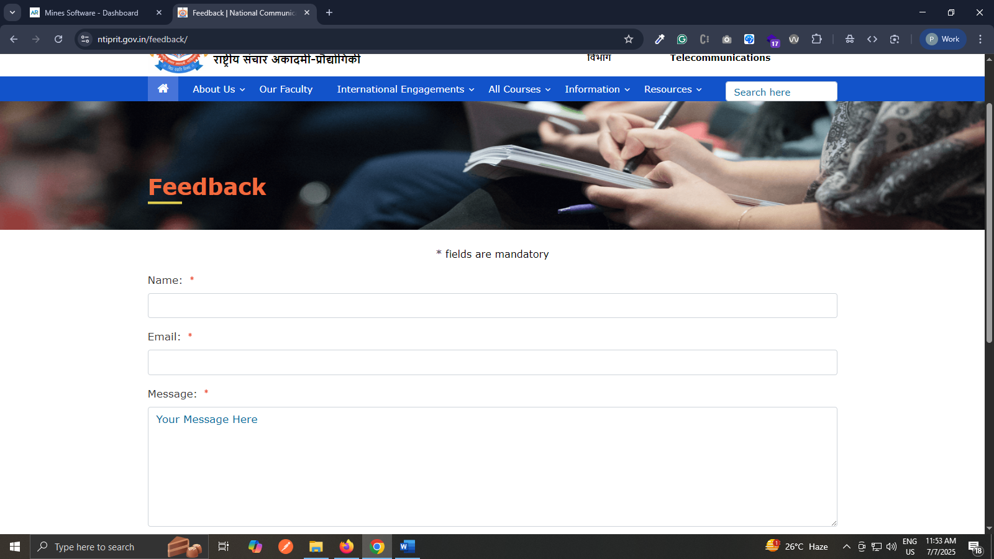

- Link to the ‘National Portal’ is present in the Homepage however pages belonging to the national portal do not open in a new browser window
done

- Several pages in the website are not responsive as they are not fitting to screen in smaller screen resolutions leading to horizontal scrolling & content overlapping. Also, the navigation bar sub-menus could not be accessed in smaller screen sizes as on expanding the link menu the link in the heard menu is getting activated

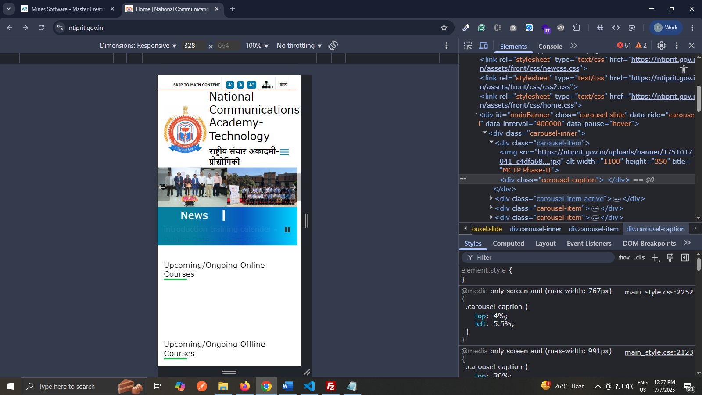

- ‘Help’ section found however it is named as ‘Accessibility Help’. The section should be labelled as just ‘Help’.
Done

- Tables in some pages are not fully visible in the print format
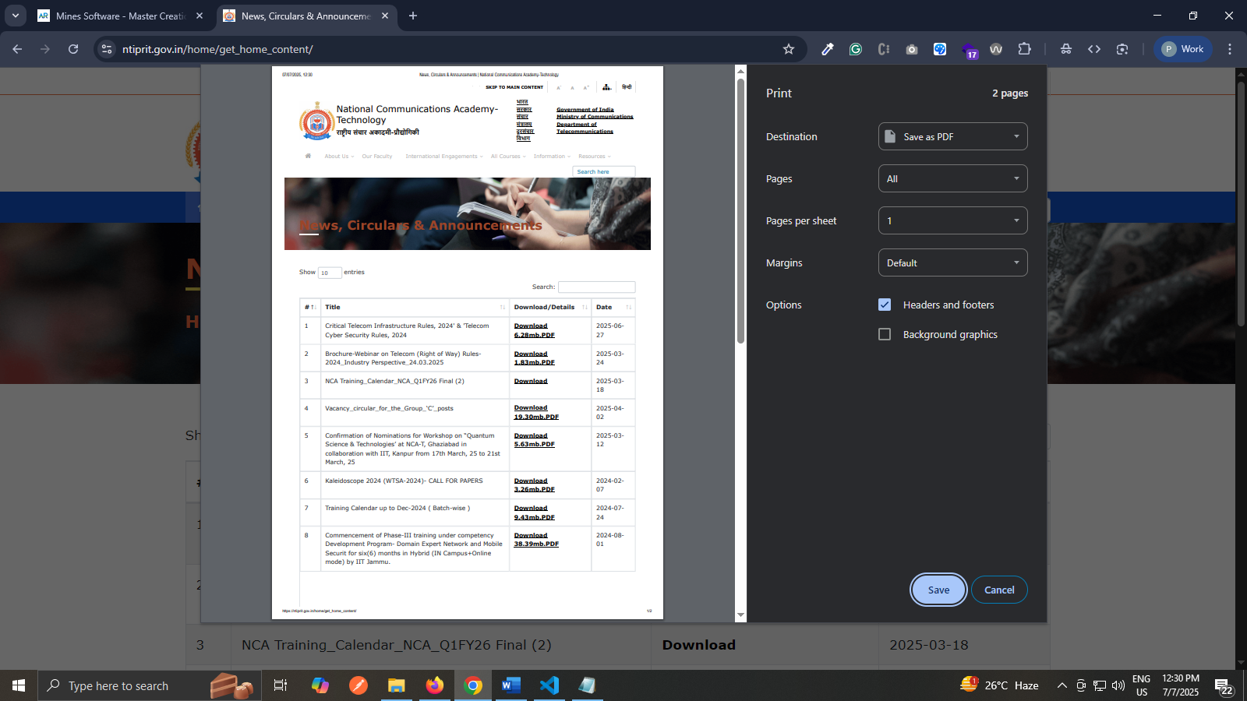

- English content found in the Hindi version of the homepage. Some content which is present in the English version is missing from the Hindi version of the website. (Like the Image descriptions in the Galley section of the Homepage) And also only the homepage of the website is present in Hindi version.
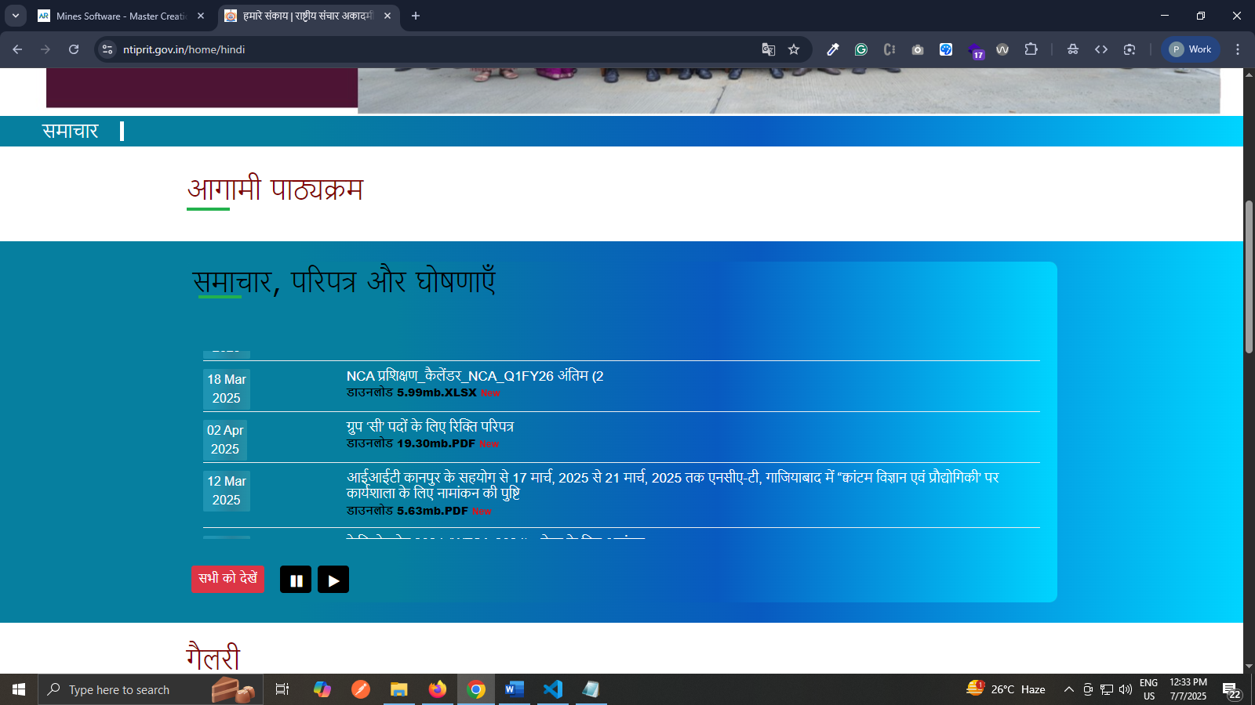

- Some documents in the website do not have proper publish date mentioned.
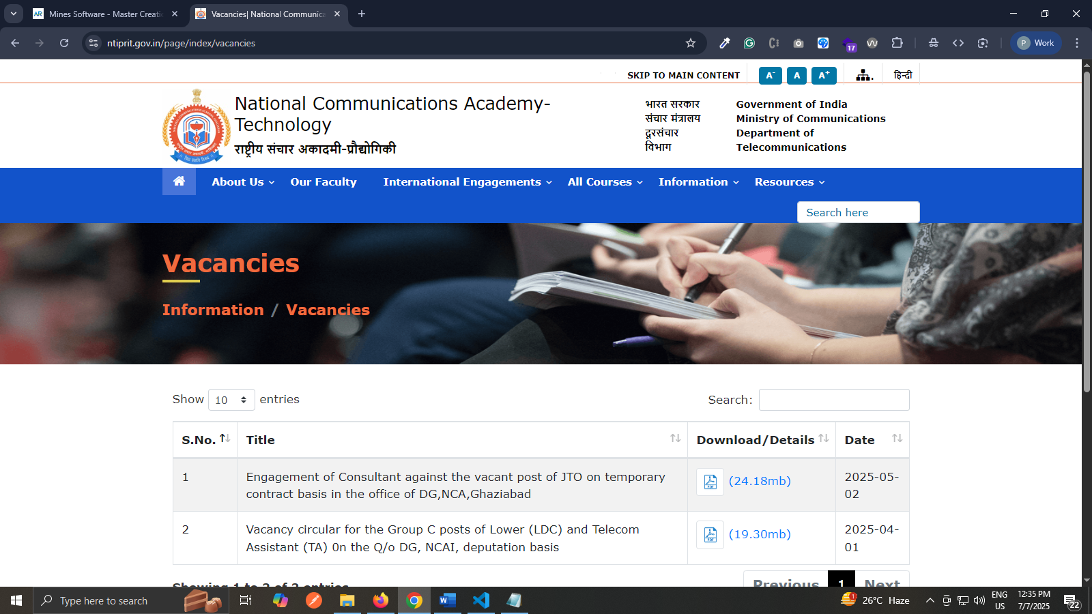

- Contrast Errors are found in the website
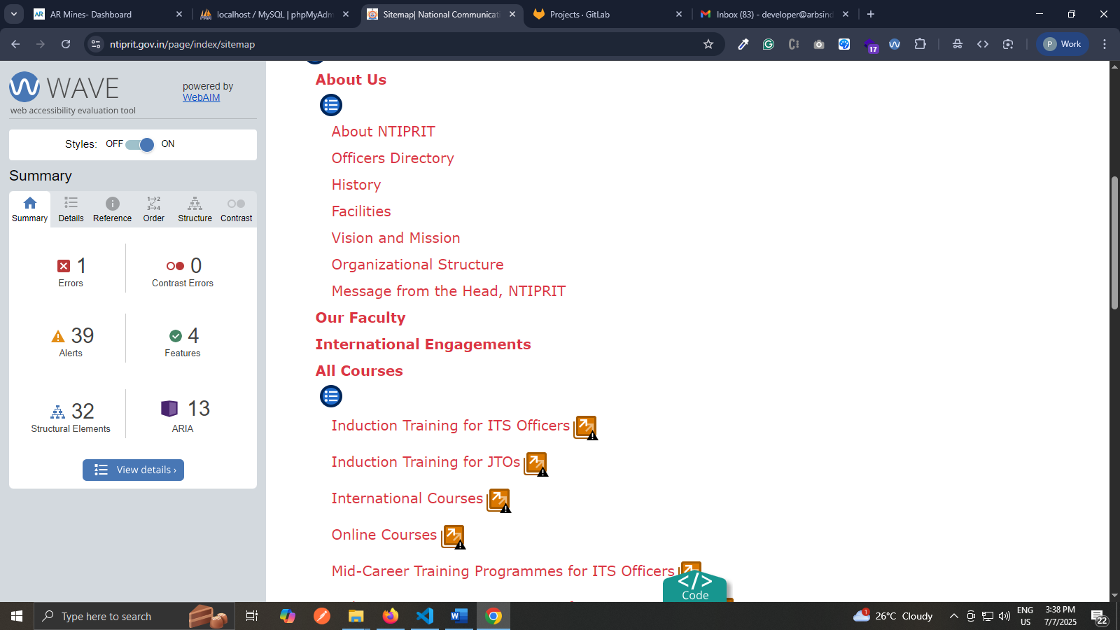
- Language change link is not clickable by mouse on increasing text size
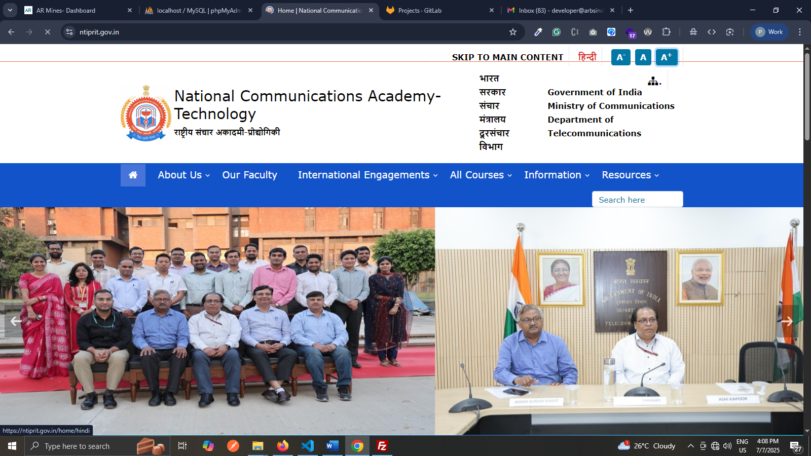
- Mechanism (button to pause, stop) auto updating content is not provided for auto updating content in the homepage of the website.

Banner mouse over banner stop.
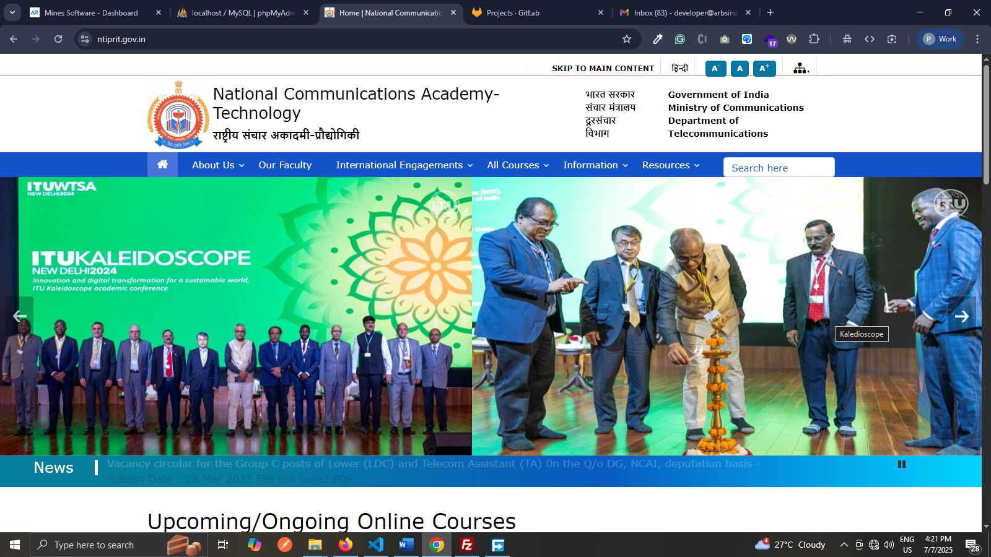
- Feedback Form is not accessible.
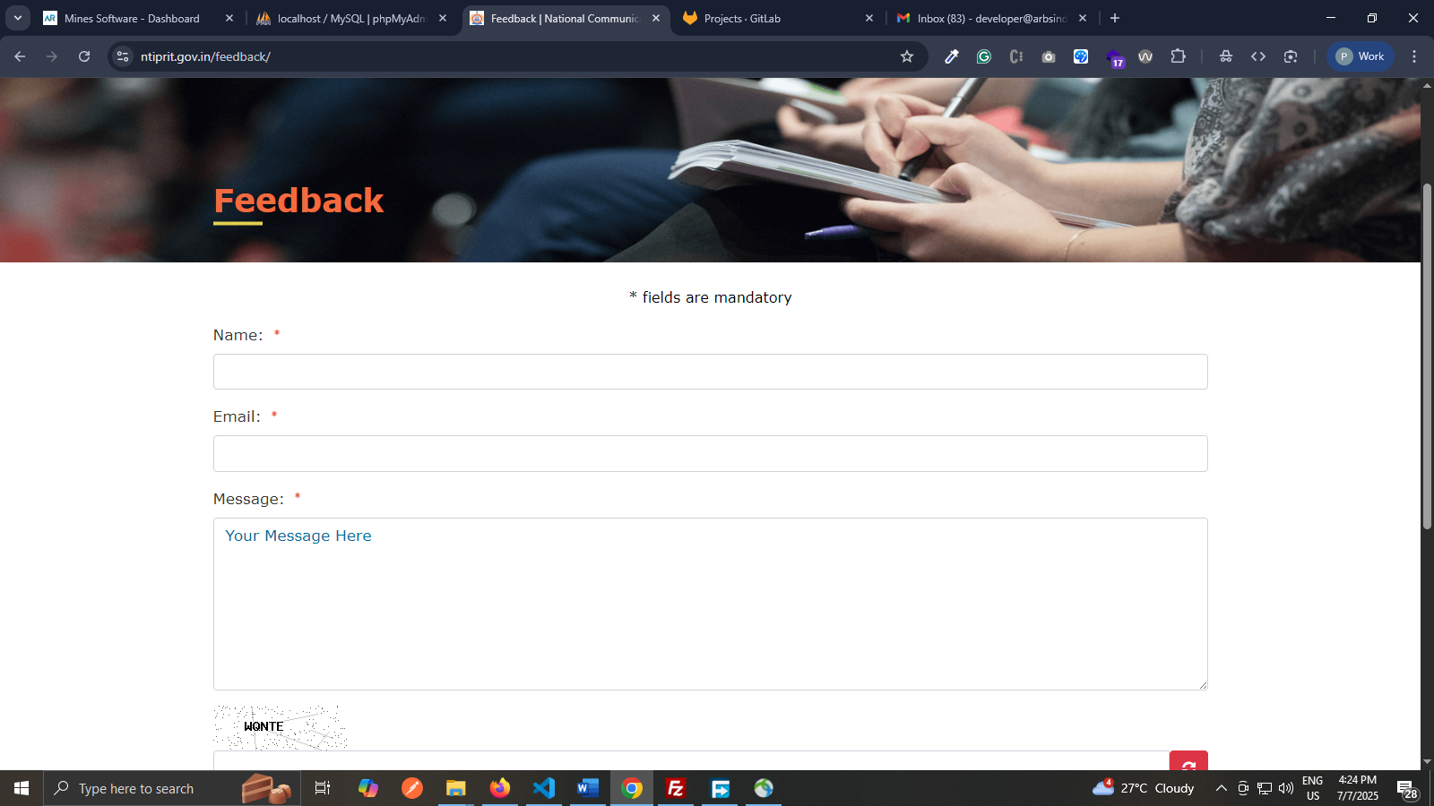
- The title of some pages are not complete. It only states the topic of the page without including the name of institute and country.
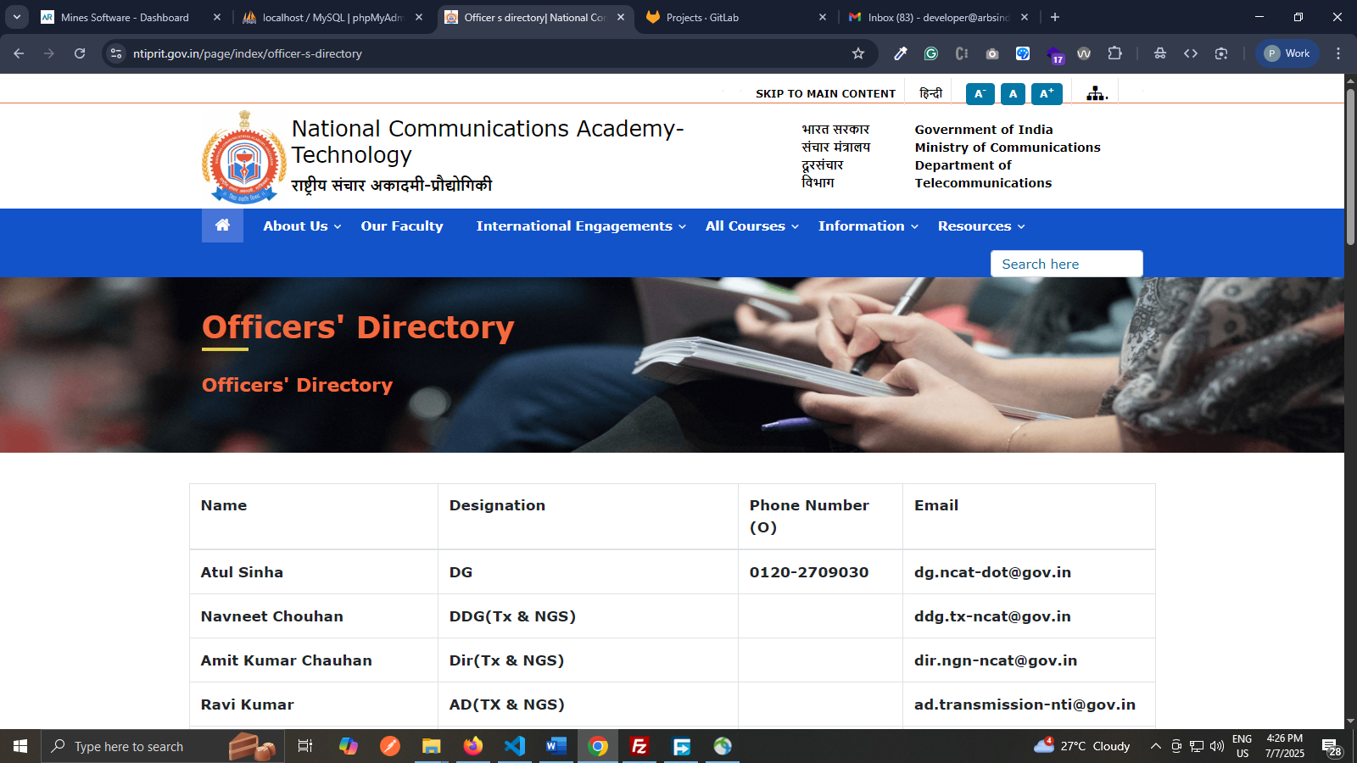

- Markup Errors are still found in the website
